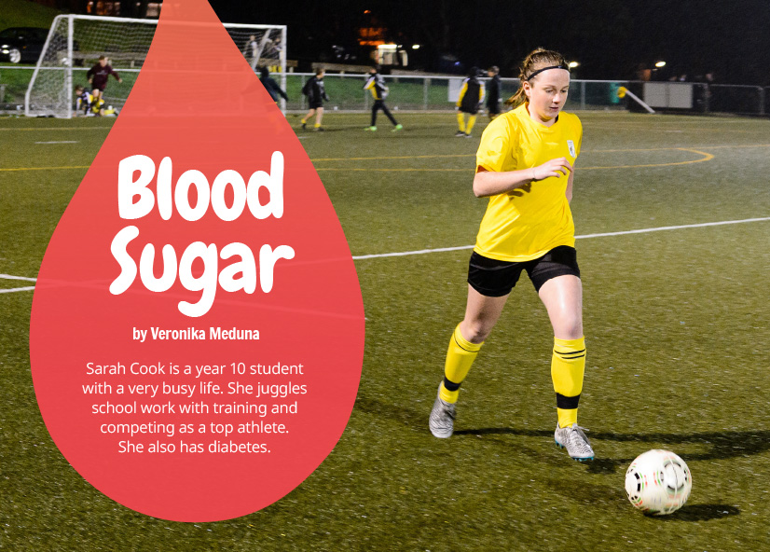
Connected
Level 3
2016

Blood Sugar
by Veronika Meduna

Overview
This article describes how year 10 student Sarah Cook manages to live a full and active life despite having diabetes. It explains what causes diabetes and allows students to compare the two main forms of the disease (type 1 and type 2).
A Google Slides version of this article is available at www.connected.tki.org.nz.

Curriculum contexts

SCIENCE: Nature of Science: Communicating in science  Level 3 – Begin to use a range of scientiﬁc symbols, conventions, and vocabulary. | Key Nature of Science ideas  Scientists:  - use common vocabulary to express their ideas and interpretations  - use diagrams to explain their ideas  - use symbols to represent materials and movement to explain how systems work and interact  - use graphs to show patterns.
SCIENCE: Living World: Life processes  Level 3 – Recognise that there are life processes common to all living things and that these occur in different ways. | Key science ideas  - The food we eat is changed into glucose in the body.  - Human bodies need glucose for energy.  - Insulin plays a part in transporting glucose into the cells of our body.  - Diabetes is a disease where the body can't properly control the amount of glucose in the blood.
ENGLISH: Reading  Level 3 – Ideas: Students will show a developing understanding of ideas within, across, and beyond texts. | Indicators  - Uses their personal experience and world and literacy knowledge confidently to make meaning from texts.  - Makes meaning of increasingly complex texts by identifying main and subsidiary ideas in them.  - Starts to make connections by thinking about underlying ideas in and between texts.  - Makes and supports inferences from texts with increasing independence.

The New Zealand Curriculum

Science capability: interpret representations

Capability overview
Scientists represent their ideas in a variety of ways. They might use models, graphs, charts, diagrams, photographs, and written text. A model is a representation of an idea, an object, a process, or a system. Scientists often use models when something is not directly observable. Models enable scientists to work on their ideas, even though they are often using a limited representation of the “thing” itself. It is important students can identify what is the same and what is different about the model and the thing. | It is important for students to think about how data is presented and ask questions such as:  What does this representation tell us?  What is left out?  How does this representation get the message across?  Why is it presented in this particular way?  This sort of questioning provides a foundation to critically interact with ideas about science in the media and to participate as critical, informed, and responsible citizens in a society where science plays a significant role.

More about the capability

The capability in action
The science capability “Interpret representations” is about students understanding information that is presented as a description or in visual form and recognising the best way to present information.  Scientific representations include diagrams, models, charts, and graphs, as well as written text.  Scientists develop models and diagrams that best represent their theories and explanations.  Scientists  Scientists use:  - representations that can help both the original scientist and others clarify, critique, and evaluate their ideas, research, and theories  - computer and other kinds of modelling to predict what might happen in certain conditions and then test these predictions to see how accurate the model or idea is  - diagrams or models to communicate science ideas  - graphs to present data  - scientific forms of text involving argumentation that use evidence to debate explanations.  Students  Students should have opportunities to:  - learn to interpret a variety of representations, including models, diagrams, graphs, and text  - develop their own representations of scientific ideas, for example, through modelling using concrete materials or using their own bodies in mime and drama  - recognise how the model or representation matches the science idea and how it is different  - consider and critique a range of representations, including scientific texts, newspaper articles about scientific matters, online information about science matters, and scientific representations developed by their peers. | Teachers  Teachers can:  - help students to be more critical consumers of science information by being explicitly critical themselves and modelling useful questions  - support students to evaluate how information is presented, for example, to assess if a graphical representation has been done appropriately or is it misleading  - ask questions such as:  - What do you think this representation tells us?  - What do the (arrows, lines, symbols, etc.) mean? (that is, help your students interpret the features)  - Is anything left out? Do you think anything is missing?  - How does this get the message across?  - Is there anything more you need to know to be able to interpret this representation?  - How does the representation make the science idea clear?  - Which aspects of this representation could mislead the reader?  - Why is it presented in this way?  - Could you suggest a better way to represent it?  - establish a science classroom culture by:  - modelling and encouraging a critical stance  - encouraging students to consider the quality and interpretation of scientific representations  - introducing learning conversations that involve interpreting, critiquing, and developing representations to demonstrate the idea's relevance in everyday life.

More activities to develop the capability

Meeting the literacy challenges

The literacy demands lie in the complexity of ideas and information around diabetes. Students will need to interpret different kinds of diagrams, for example, one representing human physiology, another representing the two types of diabetes, and a graph showing how insulin levels are tracked in the blood.  Another literacy demand requires students to understand and use biological and medical terminology to understand how diabetes affects a person’s health. | The following strategies will support students to understand, respond to, and think critically about the information and ideas in the text.  You may wish to use shared or guided reading, or a mixture of both, depending on your students’ reading expertise and their background knowledge.  After reading the text, support students to explore the activities outlined in the following pages.

INSTRUCTIONAL STRATEGIES

Finding the main ideas  Before reading the text, EXPLAIN that it is about a student who has to live with diabetes. Ask them to scan the text to get a brief overview of what is to come. PROMPT them to share what they already know about diabetes.  Throughout the reading, keep focused on the facts: type 1 diabetes can be managed and type 2 diabetes can be avoided. However, you should also bear in mind that this may be a sensitive subject for some students whose families have experience of this very serious disease.  After finishing the reading, DISCUSS how Sarah has learnt to manage her disease and how she feels about it.  What sort of life is Sarah able to live as a diabetic?  How has she achieved that life? What does she have to do to keep on top of her disease? What does she need to know? Who helps her?  What role does science play in enabling her to live that life … and what part does Sarah's own attitude have to play? How can you tell?  Using diagrams and photos to develop a deeper understanding  Point out that a great deal of the information is embedded in the diagrams and photographs. ASK QUESTIONS to help the students unpack this information.  Look at the photographs of Sarah and read the captions. What do you learn about Sarah from these photographs? What do they tell you about how diabetes affects her life and how she manages her condition? How do the photographs support the information in the text?  How do you think the pump gets insulin into Sarah's body? What image helps show this?  What do the two diagrams on page 11 show us? Why are there two diagrams? What do the different colours represent? Can you point to where you would find your own stomach and pancreas?  Look at the close-up image on page 11. Use the image to explain to a partner how the body creates insulin and what insulin does. | Take some time to explore the diagram ‘Types of diabetes’ on page 12. Prompt the students to think about the information and how they are gaining it.  How does the chart help you to learn about the two types of diabetes?  Can you think of a subheading for each section to make the information clearer?  What should you read first? What helps you to keep track of the information as you read?  What other way could you represent the information to help you understand type 1 and type 2 diabetes and help you explain them to someone else?  The illustration on page 13 outlines some of the symptoms Sarah experiences when her blood glucose level is too low or too high. Ask the students to think of another way they could represent these symptoms.  Have the students look closely at the graph on page 14. DISCUSS an appropriate sequence to follow when interpreting a graph, for example, by reading:  1. the heading  2. the key  3. the labels on the axes  4. the data within the graph.  Ask the students to IDENTIFY times when Sarah is likely to need an injection of insulin. Have them EXPLAIN their decisions to a partner and DISCUSS any differences of opinion.  Use medical terminology to explain science ideas  Point out that the author uses a number of medical terms. Ask the students to find these words to build a list of topic words, for example, “diabetes” and “insulin”. Use the following cloze activity to allow the students to REUSE THE TERMINOLOGY. Create the cloze activity from the text below. Break the text into three sections of two paragraphs each and ask students in small groups or pairs to work through the two paragraphs together. Then have the students put each piece together after they have shared their section with the class.  Consider extending this activity by having the students create their own cloze exercise to describe the differences between type 1 and type 2 diabetes.

Meeting the literacy challenges

A person will be diagnosed with diabetes when testing shows that they have too much glucose in their blood. This happens because the person’s pancreas is not making enough insulin.  Glucose is a type of sugar. It’s a good type that provides the energy that our brains and bodies need to work properly. Glucose comes from the food we eat, and we also store glucose in our liver so we don’t run out.  The level of glucose in our blood changes during the day. It goes up when we have just eaten food and the glucose from it goes into our blood: it goes down when we exercise and use some of that glucose as energy.  Insulin is a hormone that occurs naturally in our bodies. It is made in the pancreas and moves through the bloodstream. Its job is to regulate the supply of glucose so that we don’t have too much and we don’t have too little. It transports glucose through our body and switches on or off the supply from the liver, depending on whether or not we need more. | People with diabetes don’t make enough insulin. When their blood glucose levels fall, they need to inject themselves with insulin so that they don’t become hypoglycaemic. The symptoms of hypoglycaemia include becoming shaky, hungry, exhausted, and even falling unconscious. On the other hand, it is also not healthy to have too much blood glucose.  All this means that people with diabetes have to constantly measure and monitor their blood glucose levels. Insulin pumps help by delivering the right amount of insulin to the body throughout the day. However, it is still important for diabetic people to keep checking what is happening. It also helps to have a team of people to help. Diabetes nurses, doctors, and dieticians can work with people with diabetes so they can live full, active lives.  Words for selection: blood glucose, bloodstream, diabetes, diagnosed, energy, glucose, hormone, hypoglycaemic, inject, insulin pumps, level, monitor, dieticians, pancreas, regulate, symptoms, type of sugar.

Reading standard: by the end of year 6
The Literacy Learning Progressions
Effective Literacy Practice: years 5–8

TEACHER SUPPORT
Human bodies need glucose for energy.  Insulin plays a part in transporting glucose into the cells of our bodies. | 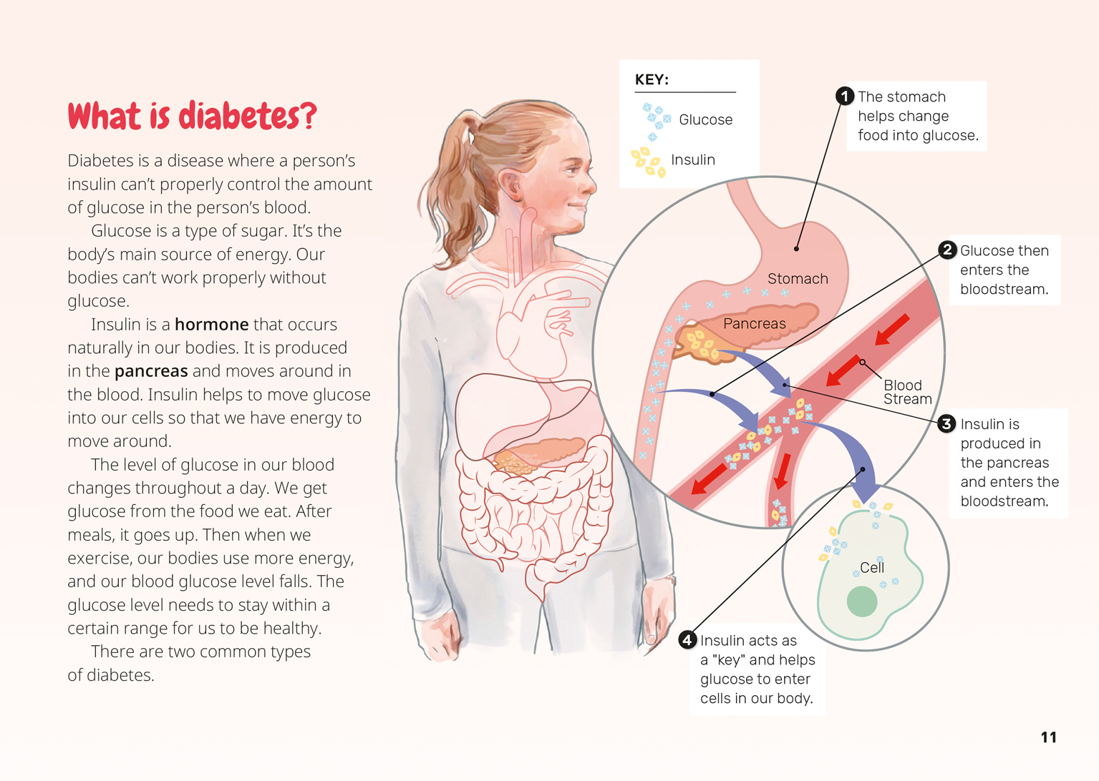  Scientists use diagrams to explain their ideas.  Scientists use symbols to represent materials and movement to explain how systems work and interact.

Learning activities – Exploring the science
The following activities are a guide for supporting students to explore and develop understandings about the science capability “Interpret representations”. Some activities focus directly on the science capability. Other activities extend students’ content knowledge across the learning areas. Adapt these activities to support your students’ learning needs.

Activity 1 – Sharing our understanding of diabetes
Arrange for the students to interview someone who has diabetes and is prepared to answer questions about it. Alternatively, arrange an interview with a diabetic nurse.
Have the students work in groups to prepare for the interview, reviewing what they learnt from the article, listing anything that they want to find out more about, and preparing suitable questions. Encourage them to refer back to the article to find the correct medical terms.
Following the interview, discuss what the students think are the most important messages about diabetes, both from the article and the interview.
Thinking about the people you know, who needs to know these messages? Present the messages in a way that will inform your audience from a scientific point of view.
How will you show the processes inside a person’s body that make insulin and control insulin levels?
How will you explain how to manage diabetes or how to avoid it?
What are some of the medical terms your audience will need to know? How will you explain them?

Activity 2 – Our changing world
Veronica Meduna is an experienced scientific communicator, who has co-hosted the science programme Our Changing World on Radio New Zealand National. Discuss how information can be communicated differently for different mediums, such as radio, print, and online.
What ways did the author present medical information in this article? Which did you find most effective? How could the information be presented better?

See “Resource links” below for two reports on diabetes from Our Changing World. The students could listen to one of these reports and compare the advantages and disadvantages of using radio, print, and the Google Slides version of this article to present medical information. Prompt the student to consider what are the best ways to communicate scientific information to the general public. (Confirm that the students understand that by “general public” we mean the community as a whole.)
Does it make a difference when listening to a radio programme if you also look at the images on the Radio New Zealand website?
Do different kinds of people need to receive information in different ways, for example, would you present information to older people in a different way from how you present it to children?
What do you think are the most effective ways of communicating with the public about diabetes?

Extending the learning
The students could research and develop leaflets or video advertisements for people their age providing information about type 2 diabetes and how to avoid it.

Activity 3 – The ethics of science
Have the students research the discovery of insulin, which involved conducting tests on animals (dogs). The research could lead to an interesting discussion about whether insulin would have been discovered if scientists had not been allowed to experiment on animals. The students could explore the humane use of animals in scientific research and the rules and ethics involved in animal testing.
If the students think animal testing is acceptable for saving human lives, prompt them to consider the ethics of using animals to test cosmetics. Is there a difference? See the link below to ANZCCART, Information on Animal Research in New Zealand, for ideas and resources that explore this issue.

Learning activities – Exploring the science

RESOURCE LINKS

Information about diabetes  Diabetes New Zealand: www.diabetes.org.nz  New Zealand diabetes statistics: www.diabetes.org.nz/resources_and_publications/new_zealand_diabetes_statistics  Physical activity and type 1 diabetes: www.diabetes.org.nz/living_well_with_diabetes/living_with_type_1_diabetes/physical_activity  Type1Day 1: a short film (25 mins) about people in the United States discovering they have type 1 diabetes and learning how to cope with it: www.youtube.com/watch?v=6zeiT7OgQqs  Science Daily. 14 March 2016. “Scientists create painless patch of insulin-producing beta cells to control diabetes”: www.sciencedaily.com/releases/2016/03/160314140741.htm  Diabetes UK (Info for teenagers) – includes links to information for students with diabetes and for teachers and staff (some videos and personal stories): www.diabetes.org.uk/Guide-to-diabetes/Teens/  Veronika Meduna. 10 September 2015. “How kiwifruit helps control blood sugar”: www.radionz.co.nz/national/programmes/ourchangingworld/20150910  Ruth Beran. 18 June 2015. “Protein, exercise, and type 2 diabetes”: www.radionz.co.nz/national/programmes/ourchangingworld/20150618  Diabetes Youth New Zealand: www.diabetesyouth.org.nz/about-diabetes  Diabetes Australia: www.diabetesaustralia.com.au  “New game helps explain type 1 diabetes”. Gaming app (aimed at 7- to 12-year-olds) designed to help children better understand type 1 diabetes and how to manage their diabetes while at school: www.diabetesaustralia.com.au/news/15249?type=articles | Science Buddies  Diabetes science project ideas: www.sciencebuddies.org/diabetes  Kids Health  Sports, exercise, and diabetes http://kidshealth.org/en/teens/sports-diabetes.html  American Diabetes Association  “The history of a wonderful thing we call insulin”: http://diabetesstopshere.org/2012/08/21/the-history-of-a-wonderful-thing-we-call-insulin/  Nobel Prize  The discovery of insulin: www.nobelprize.org/educational/medicine/insulin/discovery-insulin.html  ANZCCART  Information on animal research in New Zealand: http://anzccart.org.nz/schools/animal-research/

Learning activities – Exploring the
mathematics and statistics
The following activities are a guide for supporting students to explore and develop understandings about mathematics and statistics. Adapt these activities to support your students’ learning needs.

Activity 1 – What do the stats say?  Help the students explore the extent of diabetes by looking at the statistics on Diabetes New Zealand’s website (www.diabetes.org.nz/resources_and_publications/new_zealand_diabetes_statistics).  How many New Zealanders have diabetes?  How many people in our region have diabetes?  Which ethnic groups are most affected by diabetes? (To answer this, the students will need to find out the proportions of each ethnicity in the population.)  Now have the students examine the Diabetes Projects Trust infographic Diabetes in New Zealand to find the relative percentage of New Zealanders who have type 1 and type 2 diabetes. Discuss the role of statistics in helping a government decide where to direct funding.  How big a problem is diabetes in New Zealand?  Given the statistics shown in this infographic, what do you think our country needs to do about diabetes? | Activity 2 – Fun and fitness  The article describes how Sarah collects and analyses data to find out if she needs to take more insulin. The students may also know that a lot of sports people collect data to monitor their progress in their sport. “Fun and Fitness” is an extended unit on the NZmaths website that allows student to design a game, record measurements, and carry out a statistical investigation into the safety and health benefits of their game. It’s a fun way of addressing the need for an active lifestyle.  Extending the learning  You could also discuss how taking measurements can help people better manage their health.  What are some other situations where people measure their health or fitness? What might they measure?

RESOURCE LINKS

Diabetes New Zealand: www.diabetes.org.nz  New Zealand diabetes statistics: www.diabetes.org.nz/resources_and_publications/new_zealand_diabetes_statistics  Diabetes Projects Trust. Diabetes in New Zealand infographic (2014): www.dpt.org.nz/upload/pdfs/DPT%20infographic%20poster.pdf | NZ Maths  Fun and fitness: nzmaths.co.nz/resource/fun-and-fitness

Link to technology
The following activities are a guide for supporting students to explore and develop understandings about technological products.

Activity 1 – Design for health
Show the students the Diabetes Projects Trust infographic Diabetes in New Zealand and prompt them to notice the rapid rate of increase in people with type 2 diabetes. Discuss ways to reduce the chances of people getting type 2 diabetes. Have the students conduct further research into the health problems of type 2 diabetes, what symptoms to watch out for, and how to avoid it. They could then design and make a healthy food item for a particular purpose (for example, recovering quickly after playing sport, a healthy breakfast, school lunch items, or an after-school snack). They could also develop packaging and a marketing plan for their product.

RESOURCE LINKS

Diabetes Projects Trust. Diabetes in New Zealand infographic (2014): www.dpt.org.nz/upload/pdfs/DPT%20infographic%20poster.pdf  Food and nutrition for healthy, confident kids: http://health.tki.org.nz/Key-collections/Healthy-lifestyles/Food-and-nutrition-for-healthy-confident-kids#Technology  Nutrition websites: http://health.tki.org.nz/Key-collections/Healthy-lifestyles/Nutrition-websites | Kids Health  Sports, exercise, and diabetes: http://kidshealth.org/en/teens/sports-diabetes.html  Diabetes New Zealand: www.diabetes.org.nz

